Shop Finder

By

JASHAN

Level-6

Final Project

Table of Contents

Project Proposal 3

Goals and Objectives 3

Project Scope 3

Project Specifications 3

Target Audience 3

Project Deliverables 4

Resource Requirements 4

Project Tasks and Milestones 4

Project Assumptions 5

Project Report 5

Detail Design 6

Home Page 6

Register Page 6

Login Page 7

Add Section Category Admin View 7

All Products Admin View 8

All Products Page View 8

Category Wise Product  View 9

Product Details View 9

Project Testing 10

User Manual 10

Summary 10

System Configuration 10

User Access Levels 10

# 

# Project Proposal

## Goals and Objectives

The purpose of this project is to develop an online web application “Shop Finder”. In today scenario, there are so many online shopping sites exists on internet. So, for an end user, it is hard to find the product they want in affordable price range. The main objective of the application is providing a way to provide information of product and the place they are available. In this application there are two types of users- admin and registered visitor. Admin has different functionalities as compare to registered visitor. Admin can add, edit, delete and check details of products available at database. Registered user can access the location where these products can be available.

## Project Scope

The scope of this project is to implement an app named “Shop Finder” with the help of which view the Product and the URL where they can purchase this product online. The duration of the project is 20 working days which is equals to 4 weeks.

## Project Specifications

* Admin login/logout
* Add, edit, delete and check details of Product Section and Section Categories by admin.
* Admin can delete, edit and check Product Information available online.
* Admin can register new admins.
* Registered Visitor can login/logout.
* New Visitor can register.
* Registered Visitor capable to access URL information where he/she can purchase the product.

## Target Audience

The people who want to save the time to search the product at different sites and access them directly from our site. The age can go from 16 plus to 60 plus.

## Project Deliverables

The deliverables of the project are:

|  |  |
| --- | --- |
| Deliverable | Description |
| Final Report | This will be the final report of the project. |
| Coding | The executable code of the project will go under this. |
| Documentation | This portrays the documentation of the project. |
| Testing | All the test details will be covered in this part. |

## Resource Requirements

* Windows Operating System.
* Microsoft word for documentation.
* Asp.net MVC Framework
* 32-bit Processor and 6 GB or more RAM
* Identity framework- ASP

## Project Tasks and Milestones

|  |  |  |  |  |
| --- | --- | --- | --- | --- |
| **Tasks** | **Week-1** | **Week-2** | **Week-3** | **Week-4** |
| Brainstorming and analysis |  |  |  |  |
| Planning and initial meeting Project Proposal document. |  |  |  |  |
| Database Design and UI Design |  |  |  |  |
| Identity framework implementation |  |  |  |  |
| Coding for admin and reporter |  |  |  |  |
| Testing |  |  |  |  |
| Final Documentation and closing |  |  |  |  |

## Project Assumptions

Following are the assumption made while implementing the project:

* One admin and registered visitor will be registered by default.
* Application will be free and open source.

# Project Report

#### Functional and Non-Functional

|  |  |
| --- | --- |
| Users | Functional |
| Admin | * Login/logout * Register new admins * Admin can add, edit, delete, check details for product section and section categories of item. * Admin can edit, delete and check details for product information available at database. |
| Customer | * Can view details of all products available at database * Registered user capable to access the buying URL of products available * New customers can register for free. * Login using valid credentials |
|  | Non- Functional |
|  | * High speed * Fast Loading time * High performance and security * All browsers compatibility. |

## Detail Design

### Home Page

The main landing page of the application. On navigation bar options are- Home, Products, Register and Login. This display the all section categories view with link to Shop Now button.

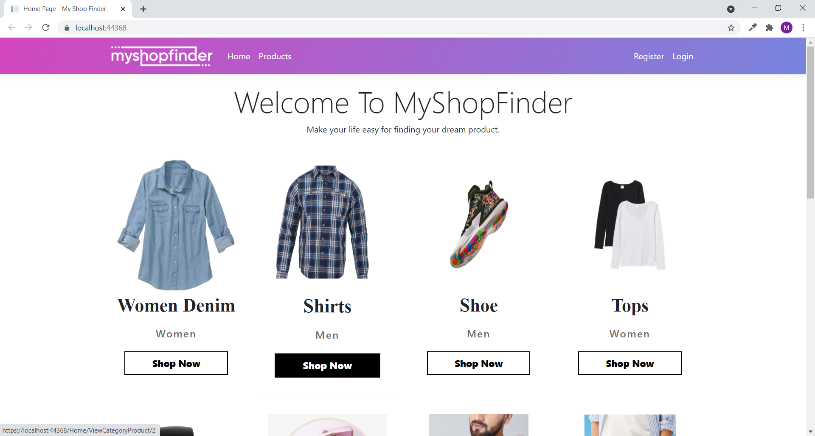

### Register Page

With the help of this page, new visitor can register online

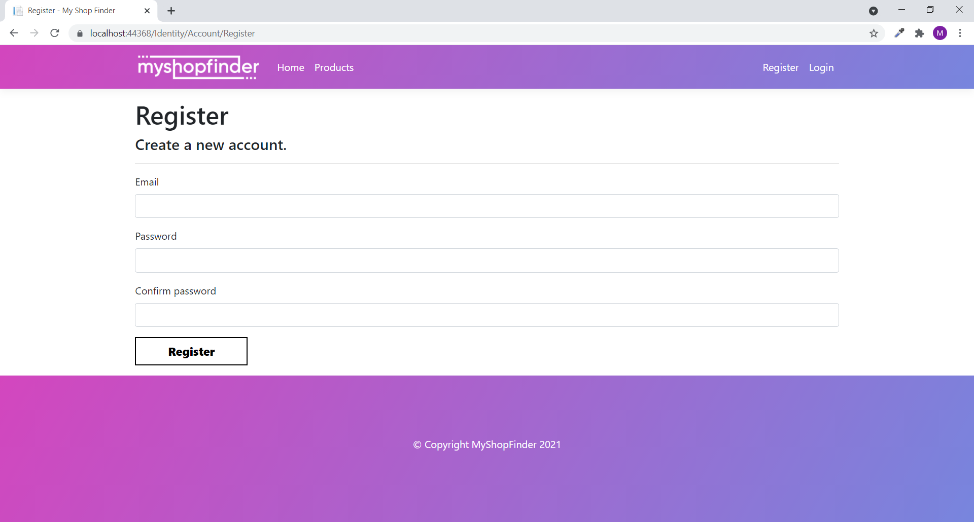

### Login Page

With the help of this page, visitor can login to page and access unrestricted page.

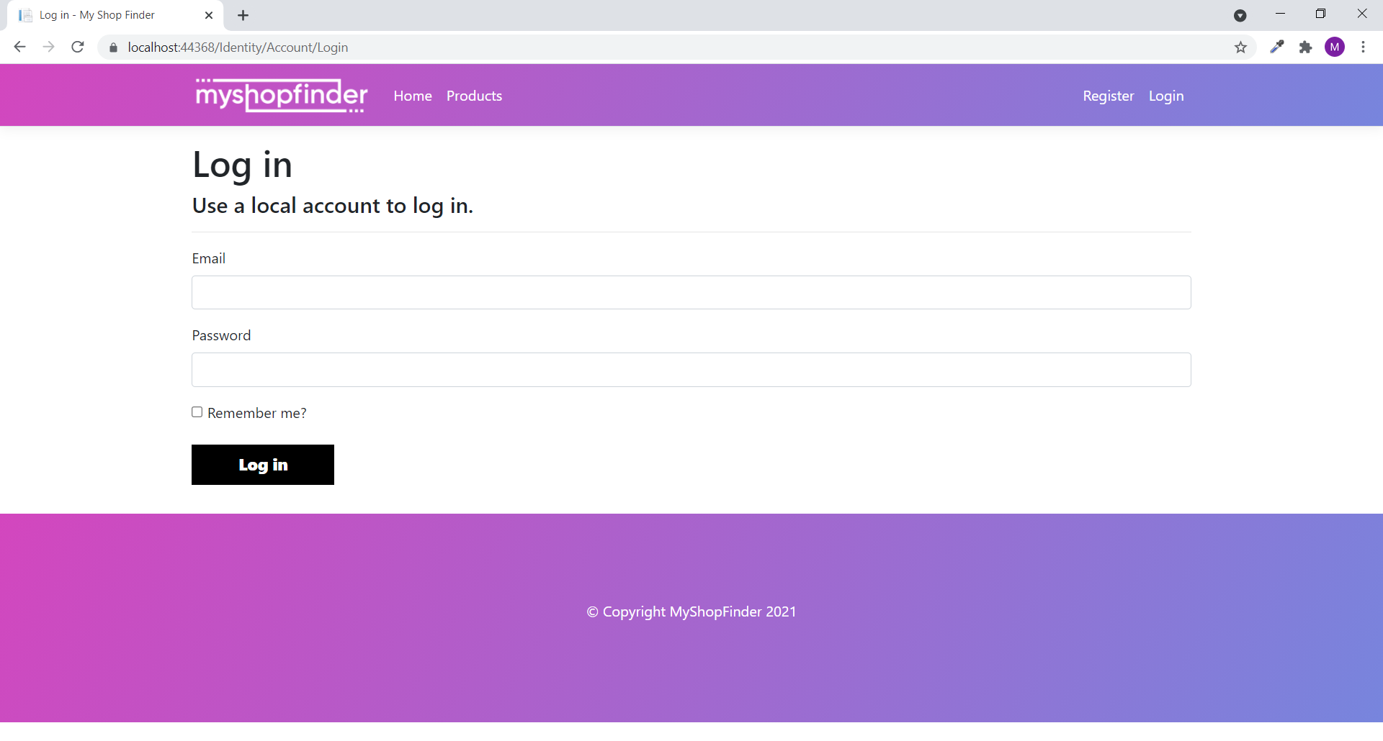

### Add Section Category Admin View

This page provides a way to add new Category of Section to database.

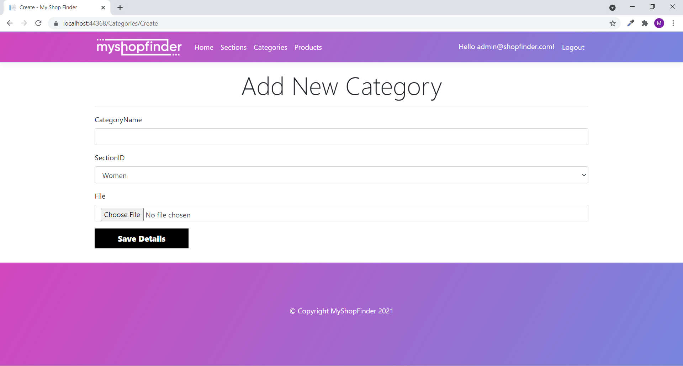

### 

### All Products Admin View

With the help of this page admin can view all products details and link to edit, delete and view their details.

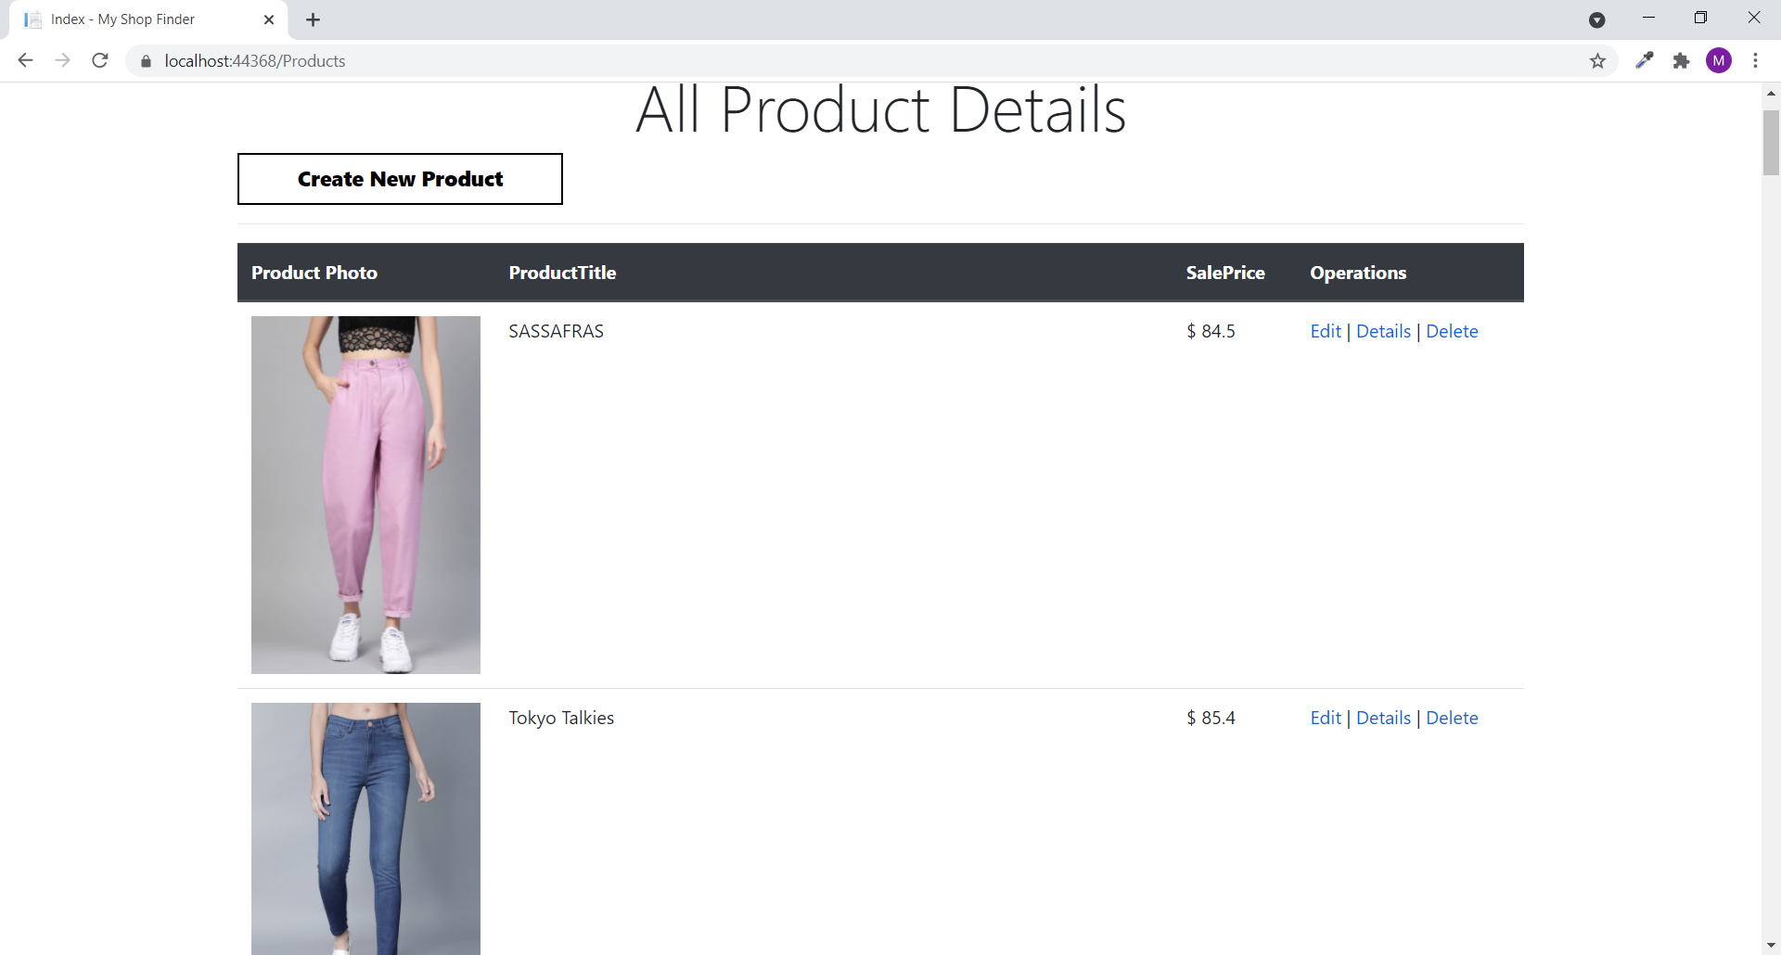

### All Product Page View

With the help of this page Visitor/Registered user can view all product information with Details link.

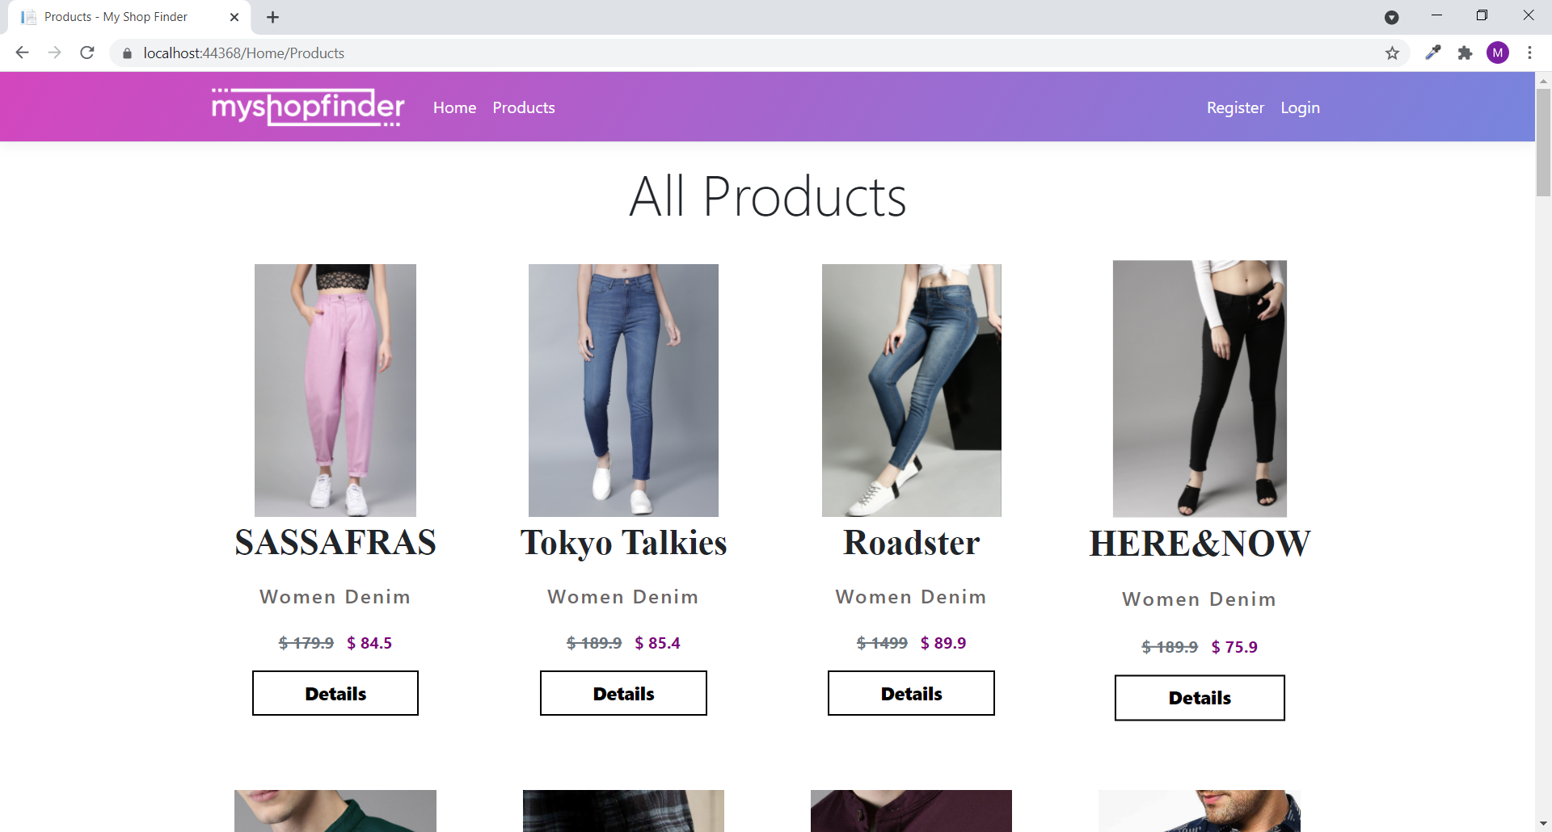

### Category Wise Product View

With the help of this page visitor can view all product of a category with Details Link.

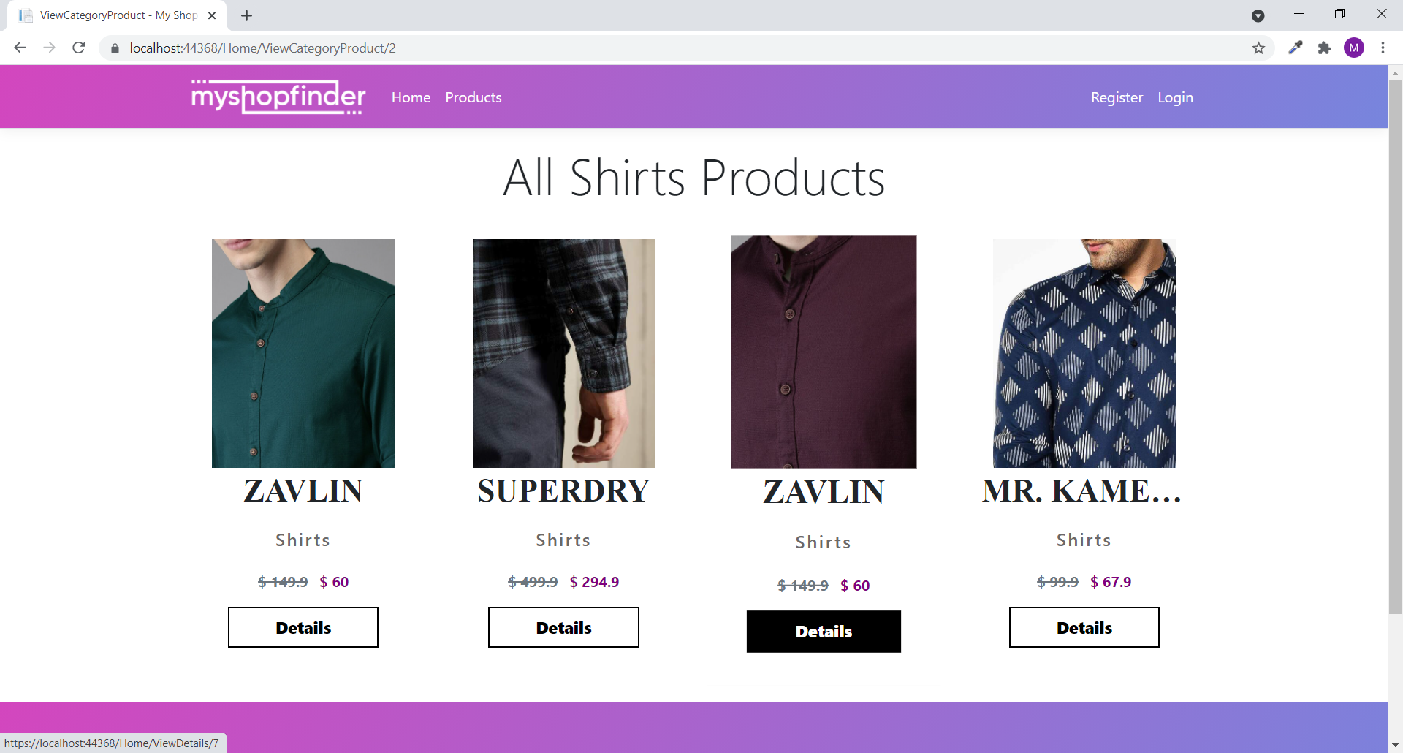

### Product Details View

This page shows the Product Details with Buy Now link to registered user.

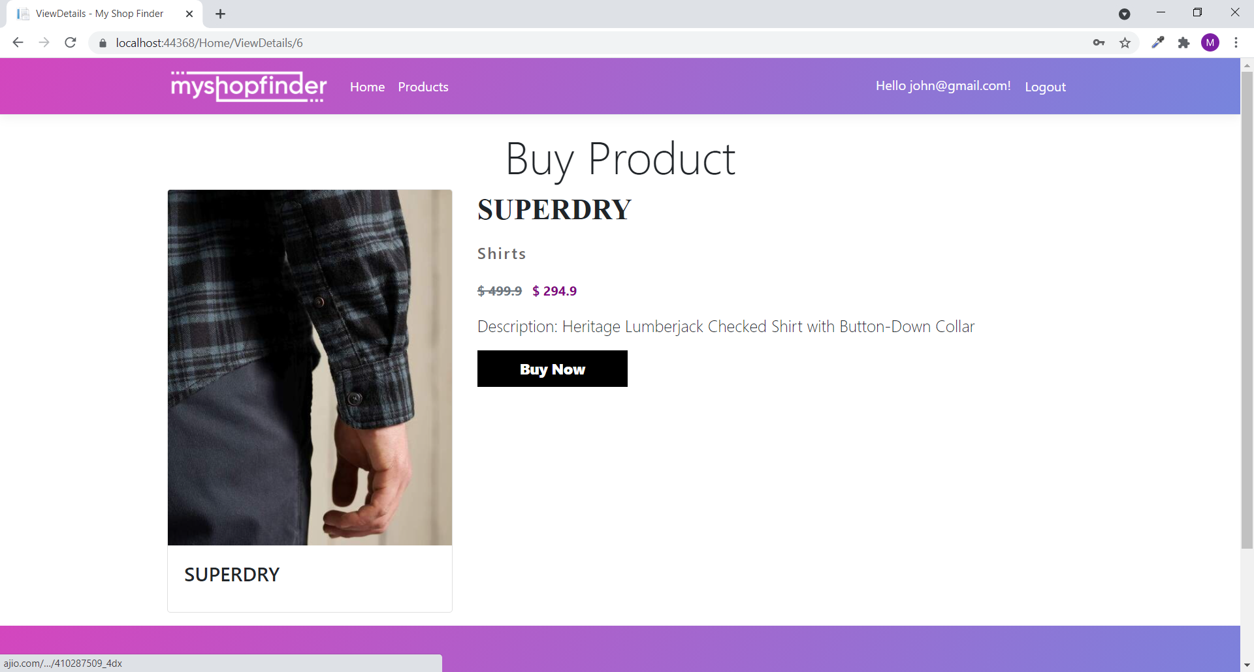

## Project Testing

The testing file for usability testing is attached as [usability test.xlsx](usability%20test.xlsx)

# User Manual

The main purpose of the application Shop Finder provide a central place of different online shopping site link of buying product to save the time of an end user. In this application there are two types of users- admin and registered user or visitor. Admin has different functionalities as compare to registered user. Admin can add, edit, delete and check details of product information available at Shop Finder. Registered User is capable to access Buy Now Link to purchase the product at his/her will.

## Summary

### System Configuration

This app will be useful to for distributing mobile information in presentable format.

### User Access Levels

Only registered users can access the features of this application.

* **Admin:** Admin has full access of the app can register new admins.
* **Registered Visitor:** New visitor can register and existing can login using their own credentials. They have limited access.